DBMS LAB 03

- Display name and job of all the teachers in UPPER, lower.

- For uppercase, we use the built-in SQL function UPPER() which shows all the data in uppercase.
- Similarly, used LOWER() for showing data in all lowercase .

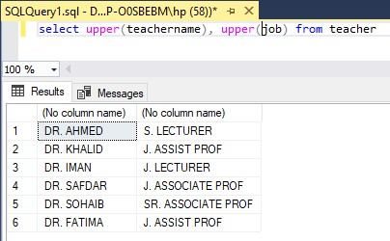

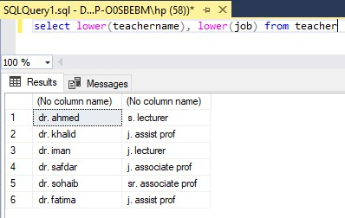

- Generate new names of the students by combining the first 3 characters of Phone Numbers and last 3 characters of Names.

- For combining the characters of phone number and last letters of name, we obtain the required characters using the SUBSTRING() function.
- Then we combined those characters using the CONCAT() function.

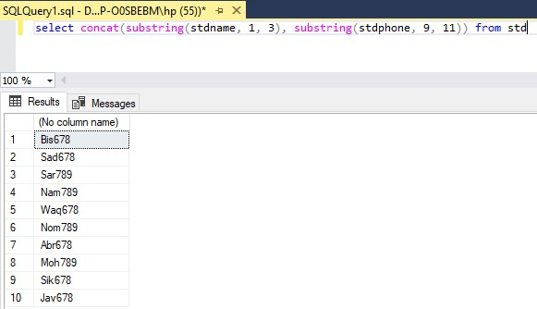

- Generate new names of the students by replacing letter ‘a’ with ‘sh’.

- For this we use the REPLACE() function, which swaps the characters in the specified field

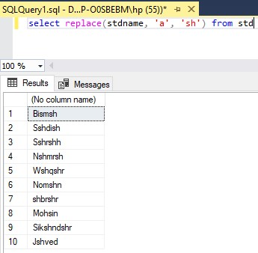

- Display Name and years served in the university by the Teacher.
- To calculate the years of services of the Teachers, we use a function DATEDIFF().
- It takes the forms of date(years, month, days, hours e.t.c) both the current date and the date of joining and subtract them to get the years of service

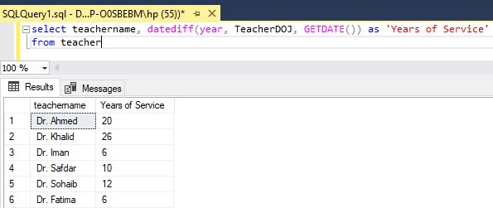

- Display name, job and date of joining of all the faculty who were born before Jan 31 2004. Keeping this in mind that joining dates should be displayed in the format “MONTH DATE, YEAR”. Also date in the where clause should be in the format “MONTH DATE, YEAR”.
- To display the name, job, and formatted date of joining for faculty born before January 31, 2004, we use the DATE_FORMAT() function.
- It ensures the joining date is displayed in the required format ("MONTH DATE, YEAR").
- The STR_TO_DATE() function is used to compare the date in the correct format.

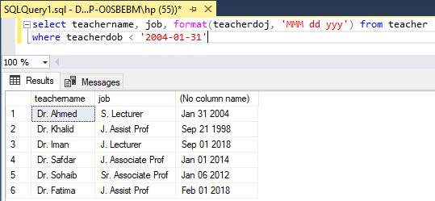

- Display the names of all teachers along with their house rent or 'Not given' if the house rent is null.
- First we check if the house rent is NULL.
- If it is NULL, we replace it with "Not given" using CASE-END conditional statement that handles null values.
- This ensures all faculty members have either a house rent amount or a default text displayed.

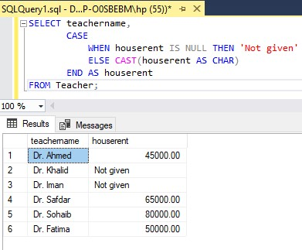

- Display teacher name, basic salary, house rent and total salary (Basic Sal + House Rent) of all the faculty members. Keeping this in mind that house rent of some of the employees might be null but total salary of an employee must not be null.

- First, we retrieve the teacher's name, basic salary, and house rent.
- We check if the house rent is NULL and replace it with 0 to avoid errors in salary calculations.
- We calculate the total salary by adding the basic salary and house rent, ensuring the total salary is never NULL.

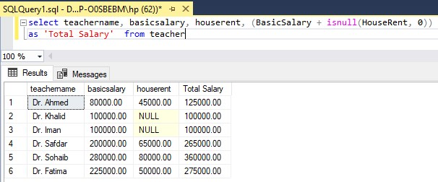

- Display the name, job, total salary, and bonus of all the faculty members. If the job is 'S. Lecturer,' calculate the bonus as 20% of the basic salary. For 'J. Assist Prof' or 'S. Assist Prof,' the bonus is 25% of the basic salary. If the job is 'J. Associate Prof' or 'S. Associate Prof,' the bonus is 30% of the basic salary. Include a column indicating whether the bonus was awarded or not.

- First, we retrieve the teacher's name, job, total salary, and bonus.
- We use a CASE-END conditional statement to determine the bonus percentage based on the job title.
- If the job matches specific roles, the bonus is calculated as a percentage of the basic salary.
- We also include a column indicating whether a bonus was awarded or not.

